**Status Bar**

*Created with the Personal Edition of HelpNDoc:* [*Easily create HTML Help documents*](http://www.helpndoc.com/feature-tour)

**Status Panels**

# Hew Lines VA7HU and Aki Yoshida JA1NLX

## 

### 3.4 Radio Control Status

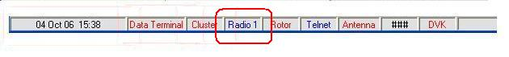

SB_13

If you place the cursor over the Radio control status, a yellow pop-up hint box will display the status of serial (COM) port configured for the ~~Radio port.~~ Radio port, Echo port and Slave port.

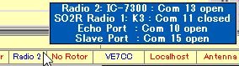

new SB_14

If you right-click on the Radio control status, a pop-up menu will be displayed providing a number of choices.

### 

### SB_14A